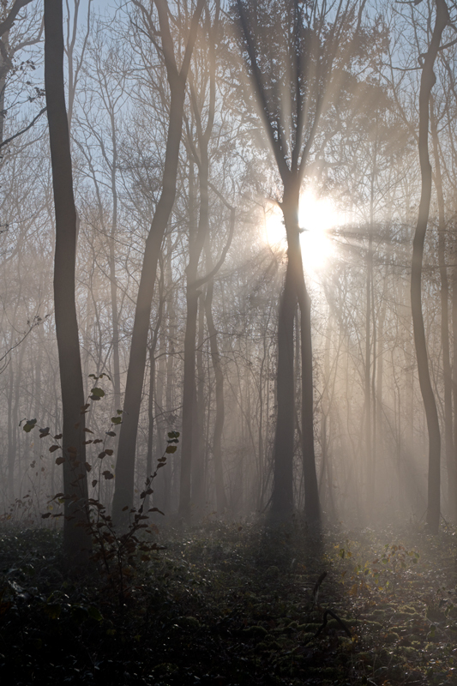
Creating Sanctuary
September 10-12th 2021
Herefordshire
In our fast-paced world, having a place of sanctuary where we can come to rest is vital for our wellbeing.
A sanctuary is both internal and external: it is a safe place where we can set down our burdens and rest without the pressure to do more or push ourselves past our limits. It is also having the space to feel, to dream, to rest in moments of refuge within.
We are sponges to our environment; we are not at all separate from it. When we surround ourselves with people and things that do not resonate with us, we are likely to be creating disharmony within ourselves – and finding a place of sanctuary can be harder.
Part of the journey to harmony is to learn to attract into our lives that which really resonates with our hearts. What places and spaces in your life offer you sanctuary? How much is your environment impacting on your inner sanctuary?
This weekend ceremony offers you the chance to understand the inner landscape of your sanctuary and how your external surroundings impact upon it. There will be opportunity to dream and create a landscape that resonates with your heart and to get a felt sense of the spacious sanctuary within each and every one of us.
This is a ceremony of stillness and nourishment, of spaciousness and rest – an opportunity to press reset and begin anew.
PRACTICAL DETAILS
We will be working from Olchon Valley Campsite, based in the Black Mountains, on the eastern edge of the Brecon Beacons National Park. This is a 2-night residential ceremony and you’ll need to arrive at 4pm on Friday 10th September and we will conclude by 2pm on Sunday, 12th September. Please note that we will be sleeping in a large yurt. The residential cost is £160 and includes supper on Friday and Saturday plus lunch on Sunday. Places are limited to 8 so early booking is advisable (a deposit of £50 secures your place).
RI FERRIER - STARMISTDREAMER
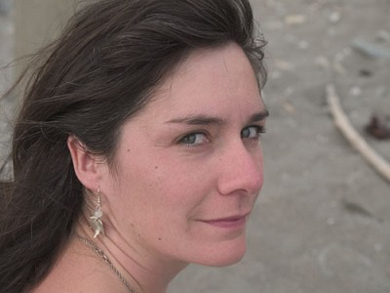
Since an early age, I’ve constantly asked the question ‘why am I here?’ and this long journey of self-discovery is ever unfolding in my life. In my 20s this found me attending meditation and Jungian based retreats and for the past twenty years it has found me studying the Beauty Way Native American Medicine path with Arwyn Dream-Walker. The teachings I have learnt weave in beautifully with my training as a Craniosacral Therapist.
My journey so far has brought me many rich and profound blessings: it has brought me a solid ground to walk upon, a framework to make sense of the world and a sanctuary to rest in. I’m passionate about making a difference in the world, about enabling others to be all that they can be and I’m passionate about walking in a way of gentleness and beauty.

BOOKING FORM- Creating Sanctuary 10-12 Sep 2021
Name _____________________________________________  Address ___________________________________________  ___________________________________________________  Tel No ____________________________________________  Email _____________________________________________  How did you hear of this retreat?  What types of trainings / retreats have you attended before?  Do you have any health restrictions? | Please answer the following:  I will look after my health needs including taking any medication prescribed for health/medical reasons  YES | NO  I will refrain from alcohol or mind altering substances during the weekend  YES | NO  I understand that the weekend may bring healing, insights, teachings and dreams. I will take full responsibility for all that this weekend brings to me.  YES | NO
PAYMENT & CONTACT DETAILS  To secure your place please send this form and a deposit cheque, made payable to ‘M Ferrier’, for the sum of £50, to the address below or email the form and BACs the deposit.  Ri Ferrier, 1 Yew Tree Cottages, Cherington,  Tetbury, GL8 8SJ.  BACs information on request. | If you have any questions or concerns, please do get in touch for a chat:  riferrier@waitrose.com |07970 555348

